No. of Pages | 5
No. of Questions | 4

BRAC University
Department of Computer Science and Engineering
FINAL EXAMINATION FALL 2014
CSE 220: Data Structures
Total Marks: 60 Time Allowed: 2 hrs 30 Mins

- Answer any Three (3) questions out of Four (4)
- Figure in bracket [] next to each question indicates marks for that
question
- Please read all the Question Carefully
- Understanding the Question is a part of exam
- All Answers should be written in the Answer Script

Question 1 (Marks 20):
- Suppose you have a Linear Array of ‘size’ elements. Write down the insertUnique() method which inserts the given element in the given index of the array only if it is unique. Do nothing if the element already exists in the array. Again, note that "size" is the number of elements in the array, which may be less than the capacity. [7 marks]

/**
* Inserts an element in the given index only if it is unique. Do
* nothing if the element already exists in the array.
* @param a the linear array.
* @param size the number of elements in the array (size <= a.length)
* @param elem the element to be inserted
* @param idx the index where the element to be inserted
* @throws noSpaceLeftException the array is already full
*/
public static void insertUnique(Object[] a, int size, Object elem, int idx) {
// TO DO
}

- Write down the printReverse() for a dummy-headed doubly linked circular list which uses the following doubly-linked Node class: [7 marks]

public class Node {
public Object elem;
public Node next;
public Node prev;
public Node(Object e, Node n, Node p){
this.elem = e; this.next = n; this.prev = p;
}
}
Question continues in the Next Page

/**
* prints the elements of the specified list in reverse order
* @param head reference to the dummy head node in the list
*/
public static void printReverse(Node head) {
//TODO
}

- Suppose you have the following Circular Array:

0 1 2 3 4 5 6 7
------------------------------------------------------- capacity = 8
| 15 | -4 | 17 | | | 2 | 7 | 9 | size = 6
-------------------------------------------------------
nextAvailPos --^ ^-- start

start--starting index of the circular array
capacity--length of the array
size--number of keys in the array
position--offset with respect to the start

Draw the resulting array after each of the following steps: [ 2 x 3 = 6 Marks]
(Hint: the array may need resizing by linearizing (resizing will change the start index). For resizing consider increasing the capacity by 3. If size==capacity first resize then insert
Step 1: insert ( by right shifting ) 40 at position=3
Step 2: insert ( by right shifting ) 30 at position=5
Step 3: insert ( by right shifting ) 24 at position=2

Question 2 (Marks 20):

- Suppose you have the following Node class:
public class Node {
public Object elem;
public Node next;
public Node(Object e, Node n){
this.elem = e; this.next = n;
}
}

Now you have to implement a stack using a non-dummy-headed singly linked linear list.

public class Stack {
private Node head; // The reference to the head node.
private int size; // The number of items on this stack.
/**
* Pushes the given element on this stack.
* @param e the element to push onto this stack.
*/
public void push(Object e) {
// TODO
}

Question continues in the Next Page

/**
* Pops the top of stack from this stack.
* @return the element that was on top before it was
* removed.
* @exception EmptyStackException if this stack is empty.
*/
public Object pop() throws EmptyStackException {

// TODO
}
}
i) Write the Stack.push() method. [ 3.5 Marks]
ii) Write the Stack.pop() method. [ 3.5 Marks]

- Evaluate the following post-fix expression using a Stack. Draw the stack to show your steps. [ 4 Marks]
8 6 3 * 4 1 - + 7 / -

- Answer the following questions: [ 3 x 3 = 9 Marks]
- Why did we use a circular array instead of a linear array to implement a queue?
- Suppose we are implementing a Priority Queue by using an array as the underlying container. We can either maintain a sorted array (by the "priority" of item) or an unsorted one. Explain how your enqueue() and dequeue() method would work for each of the two cases (Sorted/Unsorted).

- Given a priority queue, where each item has a value and a priority, you have to implement a stack using the priority queue. Describe how you would do it.

Question 3 (Marks 20):

- What type of data structure do we need while implementing (i) Binary Search and (ii) Insertion Sort? Explain why. [2 + 2 Marks]
- Given that insertion and selection sorts have the same worst-case performance, explain why one would choose insertion sort over selection sort [2 Marks]
- Given the following sequence, what are the steps to search any key using key-indexed search? (You have to draw the auxiliary array, populate it properly and explain how your algorithm would work. No codes needed) [8 Marks]
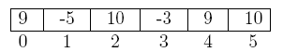

Question continues in the Next Page
- Trace the following recursion code. Draw and Write down the outputs (in your Answer Script)
[6 Marks]
public class VeryGoodVal{
public static void main(String [] args){
int val = A(5);
System.out.println( "Very Good " + val);
}

public static int A(int x){
if(x==0){
System.out.println("Good: " + x);
return 0;
}
else if(x==1){
System.out.println("Good: " + x);
return 1;
}
else if(x==2){
System.out.println("Good: " + x);
return 2;
}
else{
System.out.println("Bad: " + x);
return A(x-1) + A(x-2)+ A(x-3);
}
}
}

Question 4 (Marks 20):
- Following is the Array representation of a Binary Tree:

-------------------------------------------------------------------
| | 2 | 7 | 5 | 3 | 6 | 4 | 8 | | | 9 | 14 | | | 12 | 1 |
-------------------------------------------------------------------
0 1 2 3 4 5 6 7 8 9 10 11 12 13 14 15

Draw the Binary Tree [2 Marks]

- Write down the pre-order, post-order and in-order traversal sequence of the following tree:
[2+2+2 Marks]
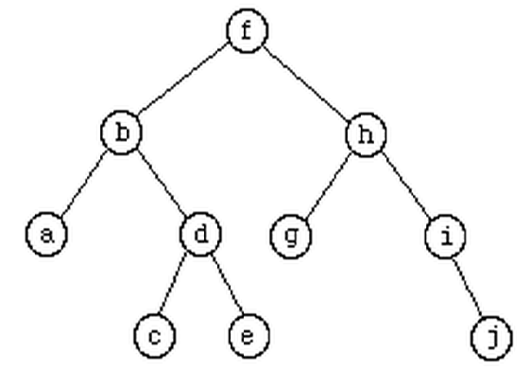

Question continues in the Next Page
- Consider the following Binary Search Tree:
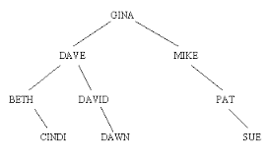

    - Remove the root, replacing it with its predecessor. Draw the resulting binary search tree.
[2 Marks]

    - Suppose we use the root’s successor instead for removing the root. Draw the resulting binary search tree. [2 Marks]

- Consider the following Directional Graph:
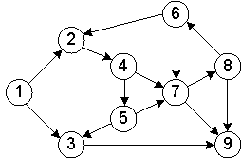
Draw the Adjacency Matrix for the above graph [5 Marks]

- Consider the following Adjacency Matrix:
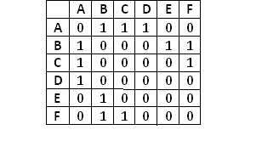

Draw the Adjacency List from the Matrix [3 Marks]

THE END

